**Software**

**Proposal**

|  |  |
| --- | --- |
| **From:** **{{sender_full_name}}​**  **{{sender_company_name}}**  Email:  Tel:   **Prepared For:** **{{recipient_full_name}}**  **{{recipient_company_name}}​​**  **{{recipient_email}}** | **Company Logo Here**  company website URL: |

## Introduction

## 

### Dear [Mr Ms] [Client.LastName],

Thanks for reaching out to [Sender.Company] regarding your upcoming development project. {{sender_company_name}} is a top provider of software development and other professional IT services. We have over [Years] of development field and a long list of satisfied customers.

Please let us know if you would like to get in touch with our existing clients from whom you will receive nothing but positive endorsements. You may also wish to review our website at [Website] to see our portfolio of previous work and learn more about our organization.

We also pride ourselves on our after-sales client-care including our guarantees, staff-training and onsite and offsite support.

Finally, we realize that you are very busy and wanted to thank you in advance for your time spent reviewing our proposal.

This proposal outlines [Sender.Company]'s proposed maintenance solution for your business to be digital. In the following sections, you'll find high level information about our work in your business and payment terms

Should you have any questions, comments, or concerns after you've thoroughly reviewed this proposal, I encourage you to leave a comment on the right hand side of your screen. I am automatically notified of any comments, and will be able to respond promptly.  
Thank you for the opportunity to earn your business!

Yours Truly,  
[Sender.FirstName] [Sender.LastName]  
[Sender.Company]

Signature

## How we work

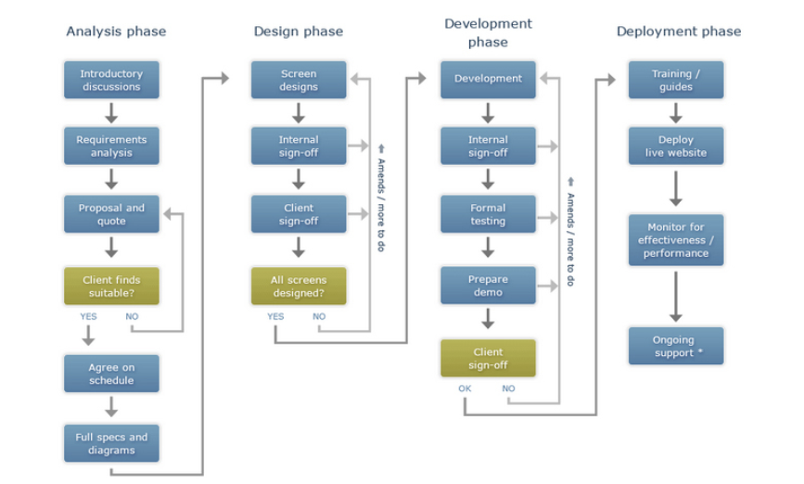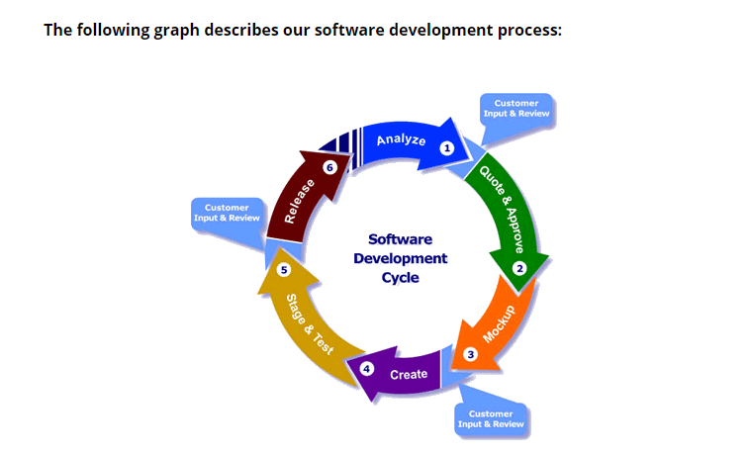

## Project Overview

* ***Proplem :***

As defined in our discussions, There is a problem related to organizing the tasks performed by the employees, since the organizing process is performed manually and traditionally, this negatively affects the productivity of the company. Company has difficulties generating accurate periodic reports, using manual and conventional procedures just to verify each report’s accuracy.

* ***Solution :***

To address your concerns, [Sender.Company] will create an admin control panel system and link it to a mobile application for employees

* ***Objectives :***
  1. Evaluate the company's current system and then develop dashboard and app to make controlling tasks digitally, smooth, and fast.
  2. Integrate the developed softwares into the company system.
  3. Organize employee training accordingly.

## Deliverables

* ***Dashboard System :***
  + - Manage hieraricay of tasks between employees
    - Admin can add employees with their positions
    - Admin can add tasks and link employees according to their position hieraricay for achieving tasks
    - Admin can keep track tasks status (new/in progress/ done)
    - Admin can add deadlines for achieving tasks
    - Create tasks report and employees report
* ***Mobile app :***

* + - App for employees only
    - Employee can login and access his profile
    - Employee can send and receive some data
    - Employee can edit some data suh as changing task status
    - employee can submit task and it is automatically sent to correct employee accroading to its position

Resources

* ***Key stakeholders :***

Business

|  |  |
| --- | --- |
| **Stakeholder Name** | **Stakeholder Function** |
| A | Project owner |
| B | Project sponsor |
| C | CEO |

Technical

|  |  |
| --- | --- |
| **Stakeholder Name** | **Stakeholder Function** |
| A | Project manager |
| B | Business Analyst |
| C | Designer |
| D | Developer |
| E | Tester |

* ***Tools and technologies :***

**Operating system**: Windows / Mac / Linux

**Language**: English / Arabic

**Hardware**: Desktop computer / Laptop / Mobiles

**Software**: Andorid/IOS app / ~~Desktop system~~ Web App

**Programming languages**: C# / SQL / React-Native

Timeline

[Sender.Company] estimates that it will take [Number.Of.Months] months to complete your new mobile app. Upon signing this agreement, we can begin immediately. Here’s what to expect:

|  |  |
| --- | --- |
| **Process** | **Delivery** |
| Planning, research/outreach | 1-2 weeks |
| Design, consultation | 4-6 weeks |
| Development | Up to 12 weeks |
| Testing, launch | 2-3 weeks |

Project Costs

This section can be used to outline and define the various costs that will go into entire project. This allows us to breakdown a detailed list of costs associated with project and define time lines and other milestones that recipients and stakeholders will be interested in.

|  |  |  |  |  |
| --- | --- | --- | --- | --- |
| Title/Description | Cost | Unit | Qty | Subtotal |
| Recruiting & Training  This will include the cost for recruiting and training each person we'll need to staff this project. | $25.00 | /recruit | 40 | $5,000.00 |
| Project Research  Describe the costs that will go into the research phase of your project.List out how many hours will be spent, and misc. costs will be incurred during this period. | $30.00 |  | 1 | $30.00 |
| Project Phase 1  Describe the costs that make up phase one of your project... | $50.00 |  | 1 | $50.00 |
| Project Phase 2  Describe the costs that make up phase two of your project... | $10.00 |  | 1 | $10.00 |

**Total Project Cost $23,000**

| **Name** | **Price** | **QTY** | **Subtotal** |
| --- | --- | --- | --- |
| Hosting | $0.00 | 1 | $0.00 |
| Standard Business Hours Support Phone & Email Support During Business Hours | $0.00 | 1 | $0.00 |

Ongoing Fees

|  |  |
| --- | --- |
| Subtotal | $0.00 |
| **Total** | **$0.50** |

The table below details monthly fees which will begin once the Web/Mobile App is successfully launched.

Terms of Agreement

**1. Authorization**

[Client.Company] is engaging [Sender.Company], as an independent contractor for the [Client.Company] web/mobile app development, deployment, hosting, & support.

#### **2. Payment**

Fees to [Sender.Company] are due in accordance with the above listed pricing table. Fees for monthly services will be invoices on the 1st business day of each calendar month, and are due on a net-30 basis. All payments will be made in [Sender.Currency] .

#### **3. Legal & License**

[Sender.Company] warrants that the functionality contained in this project will meet [Client.Company] requirements and that the operation will be reasonably error-free.

#### **4. Copyrights & Trademarks**

[Client.Company] represents to [Sender.Company] and unconditionally guarantees that any elements furnished to [Sender.Company] . for inclusion in the project are owned by [Client.Company], or that [Client.Company] has permission from the rightful owner to use each of these elements, and will hold harmless, protect, and defend [Sender.Company] and its subcontractors from any claim or suit arising from the use of such elements furnished by [Client.Company] .

Approval

If the project outline, scope, and cost are agreeable, we would ask that you approve this project proposal. We truly appreciate your time and consideration.

**I Approve This Project.**

 Signature:

Full Name:

Title: